Comms Matrix – See Page 4

ID # | Subject & Content | Page # | Audience
COMM 0 | Laptop Shipment/Pickup | Sep Doc | Targeted End User
COMM 1 | Initial Notification - What to Expect | 5 | Entire Wave
COMM 2 | Reminder - Prepare for Migration UAT | 8 | Entire Wave
COMM 3 | UAT Begin – 5 Days | 10 | Entire Wave
COMM 4 | Migration Cutover (UAT Reminder) | 13 | Entire Wave
COMM 5 | Migration Complete | 15 | Entire Wave

Migration Comms Checklists

Transition Hub/ Technology Migration Center
- M365 Migration FAQs - Complete
  - Prepare for migration by the migration FAQs document.
- Cross-Tenant Collaboration: Ways of Working - Complete
  - Navigating GCCH and Commercial (How Can I, What Can I, Where Can I).
- GCCH Technology Migration Personas (Transition Hub Section)- Pending
  - AVDs – connecting to GCCH AVD
  - Hardtokens – Authenticate to your account
  - Cellphones –
  - Telephony Softphones -
- Migration Acceptance Testing Guidance - Complete
  - SA-TECH-IMTS Technology Migration - Home
  - Need instructions on management and tasks > point to IMTS SharePoint

Technology Migration User Guidance – KB (All IMTS)
- Technology Migration Quick Reference Guide - Complete
  - Outlook, Teams, SharePoint, OneDrive, OneNote
  - Email Encryption –
  - NG Signature – update NG to inform and redirect customers to serco-na.us
  - Serco Signature – standard Serco signature formatting
  - Sensitivity Labels
  - MFA Hardtokens / (Non-Laptop Users)
    - YubiKeys / MSFT Authenticator Passkey

User Guides/KBs – UPDATES NEEDED
- GCCH Laptop Setup - Complete
  - WHfB - EID
- GCCH Account KB - Pending
  - Technology - GCC High - How to Register for Serco-na.us MFA and Password Self-Service
- GCCH AVD Log in – Pending
  - Password
- Hard Tokens – Pending
- Email Sensitivity Labels - Pending

Comms Calendars by Wave

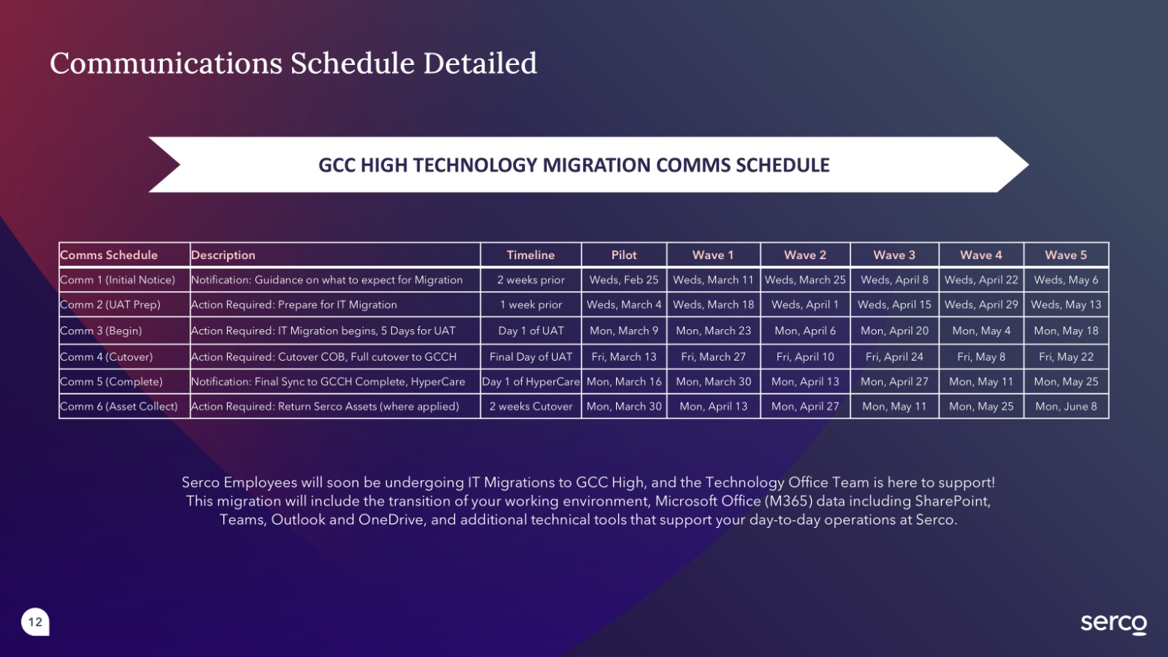

Pilot (3/27 Migration – 96 users – A+)

 |  | Pilot Wave Comms Calendar
ID # | Subject & Content |  | Date | Time | Recipient
COMM 1 | Workstation Deploy/GCCH Preview |  | 3/9 | Flexible | Commercial
COMM 2 | Reminder – UAT begins Monday |  | 3/18 | Flexible | Commercial
COMM 3 | UAT Begins |  | 3/23 | 8:00 am | Both
COMM 4 | UAT – Final Reminder/Cutover |  | 3/26 | 12:00 pm | Both
COMM 5 | Migration Complete |  | 3/30 | 8:00 am | Both
Post-migration support bridge ends |  |  | 3/19 | 1:00 pm | Hub Update
Return Serco Assets (limited distro) |  |  | 3/30 | Flexible | Both

Wave 1

 |  | Wave 1 (DMO) Comms Calendar
ID # | Subject & Content |  | Date | Time | Recipient
COMM 0 | Laptop Shipment/Pickup |  |  | NA | Targeted End User
COMM 1 | Initial Notification - What to Expect |  | 8/27 | Flexible | Commercial
COMM 2 | Reminder - Prepare for Migration UAT |  | 9/3 | Flexible | Commercial
COMM 3 | UAT Begin – 5 Days |  | 9/8 | 8:00 am | Both
COMM 4 | UAT reminder |  | 9/12 | 8:00 am | Both
COMM 5 | Migration Complete |  | 9/15 | 8:00 am | Both
Post-migration support bridge ends |  |  | 9/18 |  | Hub Update

Wave 2

 |  | Wave 2 (SATCOM & OPS) Comms Calendar
ID # | Subject & Content |  | Date | Time | Recipient
COMM 0 | Laptop Shipment/Pickup |  | TBD | NA | Targeted End User
COMM 1 | Initial Notification - What to Expect |  | 9/11 | Flexible | Commercial
COMM 2 | Reminder - Prepare for Migration UAT |  | 9/17 | Flexible | Commercial
COMM 3 | UAT Begin – 5 Days |  | 9/22 | 8:00 am | Both
COMM 4 | Migration Cutover |  | 9/26 | 8:00 am | Both
COMM 5 | Migration Complete |  | 9/29 | 8:00 am | Both
Post-migration support bridge ends |  |  |  |  | Hub Update

Wave 3

 |  | Wave 3 (Interactive Training) Comms Calendar
ID # | Subject & Content |  | Date | Time | Recipient
COMM 0 | Laptop Shipment/Pickup |  | TBD | NA | Targeted End User
COMM 1 | Initial Notification - What to Expect |  | 9/24 | Flexible | Commercial
COMM 2 | Reminder - Prepare for Migration UAT |  | 10/1 | Flexible | Commercial
COMM 3 | UAT Begin – 5 Days |  | 10/6 | 8:00 am | Both
COMM 4 | Migration Cutover |  | 10/10 | 8:00 am | Both
COMM 5 | Migration Complete |  | 10/13 | 8:00 am | Both
Post-migration support bridge ends |  |  |  |  | Hub Update

Wave 4

 |  | Wave 4 (MCTP) Comms Calendar
ID # | Subject & Content |  | Date | Time | Recipient
COMM 0 | Laptop Shipment/Pickup |  | TBD | NA | Targeted End User
COMM 1 | Initial Notification - What to Expect |  | 10/8 | Flexible | Commercial
COMM 2 | Reminder - Prepare for Migration UAT |  | 10/15 | Flexible | Commercial
COMM 3 | UAT Begin – 5 Days |  | 10/20 | 8:00 am | Both
COMM 4 | Migration Cutover |  | 10/24 | 8:00 am | Both
COMM 5 | Migration Complete |  | 10/27 | 8:00 am | Both
Post-migration support bridge ends |  |  |  |  | Hub Update

SERCO TEMPLATE

Comm 1- GCC High Workstation Deployment
March 9
- Subject: GCC High Laptop Survey
- Audience: Pilot Wave (90 Users)
- From: GCCH Transition Center
- To: Serco Commercial Emails


This message was sent to employees who will be migrating to GCC High during the week of March 23 and includes important information about your upcoming migration.

Migration Overview

The Serco Technology Office will be migrating your Microsoft 365 (M365) data, including Email, OneDrive, SharePoint, and Teams from your commercial Serco-NA.com account to a new Government Cloud Community (GCC) High Serco-NA.us account over the weekend of March 23. This migration is required to ensure we remain in compliance with U.S. Government security and contract requirements. When the migration is complete, you will be working from your Serco GCC High environment.

What Do I Need to Do?

There are a few things that you can do to prepare for this migration:

- Complete the GCC High Laptop Deployment Survey by March 11 - This survey will help IT to ensure the workstation, software and day-to-day operational needs of your team are met during this migration. You must be logged into your Serco-na.com account to access this survey.

 | Complete GCC High Workstation Survey  Due Wednesday, March 11  Click here to complete the survey

- Familiarize yourself with the GCC High Technology Migration Center – The Technology Migration Center is the centralized hub for all migration related information, support, and resources. Click HERE or on the banner below to access the Technology Migration Center.


- Monitor your Serco Commercial (.com) email inbox – More information about your technology migration, including your migration timeline, and instructions to prepare your system for migration, will be sent to your Serco email inbox.

GCCH Data Migration Comm 2 – Prepare for UAT
- Deploy Date: Thurs, April 23 by 1:00 PM ET
- Subject: Notification: Prepare for your GCC High Migration UAT
- Audience: Pilot + Wave 1 (180 - Agile / 86 - SI2)
- From: GCCH Transition Mailbox
- To: Serco Commercial and GCCH Emails

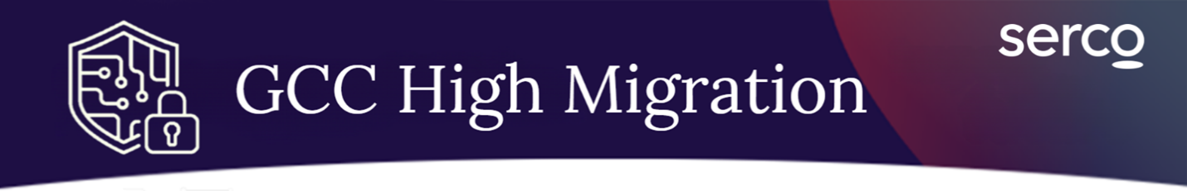

This message was sent to employees who will be migrating to GCC High during the week of April 27 and includes important information about your upcoming migration.
The Serco Technology Office is getting ready to migrate your Microsoft 365 (M365) data, including Email, OneDrive, SharePoint, and Teams from your commercial Serco-NA.com account to a new Government Cloud Community (GCC) High Serco-NA.us account. This migration is required to ensure we remain in compliance with U.S. Government security and contract requirements. When the migration is complete, you will be working primarily from your Serco GCC High environment.

A high-level overview of milestones and actions for your migration wave is listed below:

GCC High Migration Schedule
 | Today | Notification is sent previewing migration actions.
Mon, April 27  Noon ET |  | User Acceptance Testing (UAT) Kickoff.  Instructions will be sent to your commercial and GCC High email accounts.
Fri, May 1  COB ET |  | Final Day to complete UAT.
Fri, May 1  6pm ET |  | Data Cutover period begins.  Your data will be synced over the weekend outside of business hours.
Mon, May 4  6am ET |  | Data cutover is complete. HyperCare begins.  You will now be working from your Serco GCC High (Serco-NA.us) account.

Beginning Monday, May 4, you should begin working primarily in the GCC High environment. You will receive next steps to return your commercial workstation.

Next Steps:

There are a few things that you should do to prepare for this migration:

- Familiarize yourself with the GCC High Technology Migration Center –
The Technology Migration Center is the centralized hub for all migration related information, support, and resources. Click HERE or on the banner below to access the Technology Migration Center.


- Update your email signature: Update your email signature to inform customers and colleagues of your migration date and direct them to your serco-na.us GCC High email.

- Attend the upcoming GCC High UAT Kickoff Call – In this optional session, our Technology Office will provide an overview of the data migration timeline and walkthrough instructions to support Serco teams during transition.

 | Date: Monday, April 27  Time: NOON ET  Click Here to Join the UAT Kickoff  Meeting ID: 211 870 372 992 890  Passcode: wH7Nb6gt

On Monday you will receive an email invite with instructions to complete UAT. You will have until noon ET on Friday, May 1 to complete UAT, during which you will be asked to review your migrated environment and certify that your files have migrated correctly. The time requirement for this activity may vary depending on how many files you have in your Serco commercial account. If you need help, the Technology Migration team will host a UAT Kickoff call on Monday, April 27 at 12pm ET to walk through the step-by-step instructions, followed by a UAT support session later in the week. A link to join this support session will be shared again on Monday.

Additional Resources

Visit the Transition Hub for more information about your data migration. Here, you will find an overview of key tasks related to your specific migration timeline, support contacts, FAQs, and information about receiving your GCC High laptop, if applicable.

IMTS Data Migration Comm 3 – UAT is Live
March 23
- Subject: ACTION REQUIRED: Complete Migration UAT by Friday at 12pm ET
- From: GCCH Migration Inbox
- To: GCCH & Commercial

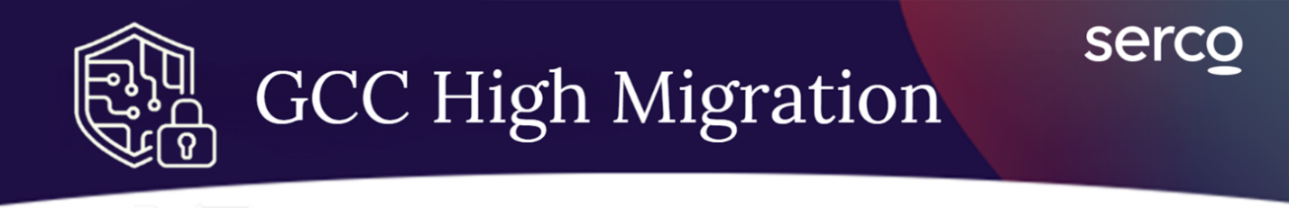

This message was sent to employees who will be transitioning to GCC High on Monday, March 30. This was sent to both your Serco commercial and GCC High accounts.

Complete UAT Testing by Friday at 12pm ET

Please complete User Acceptance Testing (UAT) for your Government Community Cloud (GCC) High migration by Friday, March 27 at 12:00 pm ET.
Attend the upcoming GCC High UAT Kickoff Call – In this optional session, our Technology Office will provide an overview of the migration timeline and instructions to support Serco teams as you transition.

 | Date: Monday, March 23  Time: NOON ET  Click Here to Join the UAT Kickoff  Meeting ID: 245 455 459 879 79  Passcode: Bv9ic6B9

What Do I Need to Do?

During UAT you will be comparing your new GCC High environment to your commercial environment. You must confirm that your data is migrating correctly using the Migration Registry, Instructions to confirm your UAT are provided within the registry homepage. You must access this registry from your GCCH environment.

As you begin UAT, keep in mind:
- Please be patient when accessing the data for the first time. If you have large amounts of data, your data may continue to load from the cloud throughout your UAT testing period. Rest assured, all data from before March 16 is expected to be available by the end of the testing window.
- Use your GCC High environment for this testing only. New data could be overwritten or duplicated once data cutover occurs.

Follow the steps below to complete UAT for each M365 Application:

- Exchange (Outlook) & OneDrive: Check that your email, contacts, and tasks are available. Confirm your OneDrive files and folders are copied. Your calendar data and any files added after March 16 will appear after cutover. Once complete, approve the Exchange and OneDrive section in the Migration Registry.

* Use this guide for detailed instructions to approve UAT for Exchange and OneDrive.

- If you are a SharePoint Owner: Verify you have access to all owned SharePoint sites and confirm content and item count. Files added after March 16 will appear after cutover. Use this guide for detailed instructions to approve SharePoint UAT.

- Teams (optional – but recommended): Make sure you can access all teams and channels. Channels added after March 16 will appear after cutover.


*Access from GCCH Serco Environment

Continue to prepare your environment for migration cutover:
- Your cutover will begin at 6:00 pm ET on Friday, March 27 and will be completed by 6:00 am ET on Monday, March 30. Refrain from deleting content, renaming folders or moving content within both Serco environments until your data cutover is complete.
- If you have encrypted email messages that you wish to maintain access to, you will need to export your Serco Commercial Encryption Certificates to your Serco environment. More guidance on this scenario will be provided.

Where do I go for Help?

Visit the Transition Hub for more information about your data migration and a link to our support inbox. Here, you will also find an overview of key tasks related to your specific migration timeline and FAQs to support your account transition.

UAT Support Bridge
Our Technology Migration team is hosting a hands-on support bridge at various times during the week for any employee who needs UAT support.

UAT Support Bridge hours:  Wednesday, March 29: 12-1pm ET | Meeting Information:  Click to join the Support Bridge  Meeting ID: 276 180 049 978 84  Passcode: ew2SY9RQ

GCC High Migration Comm 4 – UAT Final Reminder

March 26, noon
- Subject: Final Call for UAT - Your GCC High Cutover begins tomorrow
- From: GCCH Transition inbox
- To: Serco Commercial & GCCH email

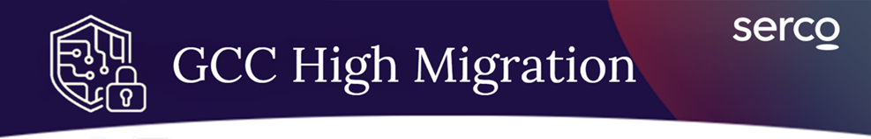
This message was sent to employees who will be transitioning to GCC High on Monday, March 30. This was sent to both your Serco commercial and GCC High accounts.

TODAY: Complete UAT by COB ET & Close out all M365 Applications by 6pm ET

Your final data cutover will begin today at 6:00 pm ET and will last until Monday, March 30 at 6:00 am ET. Please ensure you have completed all tasks listed below prior to final cutover. Beginning on Monday, you will work primarily from your Serco GCCH environment.

- Complete User Acceptance Testing (UAT) by COB ET: If you have not already completed and confirmed UAT in the Migration Registry, reference the instructions in the next section to complete this task.

- Close out of all M365 applications by Friday at 6:00 pm ET. This includes email, OneDrive, SharePoint, and Teams. Check-in any checked-out files within SharePoint prior to closing out your applications.

- After you close out of your applications this evening, do not perform work in your Serco GCCH account until Monday, March 30 at 6:00 am ET. Any files created or modified during this migration window could fail to migrate or be overwritten.

- Teams Telephony

On Monday, you will receive an email confirming your migration is complete, at which time your data will be 100% migrated to the GCC High environment. You should work from your GCC High environment exclusively moving forward.

Instructions for Completing UAT

Log into your Serco GCCH account and access the Migration Registry where you will find instructions on how to use the site and approve your UAT. Please note as you move through your UAT, your calendar data and any data added over the past two weeks may not be reflected until your formal data migration occurs this weekend.

- Exchange (Outlook) & OneDrive: Check that your email, contacts, and tasks are available and confirm your OneDrive files and folders are copied. Once complete, approve the Exchange and OneDrive section of the Migration Registry.

*Use this guide for detailed instructions to approve UAT for Exchange and OneDrive.

- SharePoint: If you are a SharePoint owner, verify you have access to all your sites and the item count, and confirm in the SharePoint section of the Migration Registry.

Next Steps

Your Commercial M365 data and resources will be put into read-only on Monday, March 30, meaning you will no longer have access edit or modification capabilities to commercial files. Our Technology Office is working closely with Business Champions to finalize next steps to turn in your Serco Commercial issued workstations (if applicable).
In the meantime, unless you are instructed to do otherwise by your leadership, please keep these assets in a safe place under your personal control until further guidance is provided.

If you have a Serco issued Commercial mobile phone, you will receive separate guidance to support your mobile transition to GCC High.

Where do I go for Help?

Visit the Transition Hub for more information about your data migration and a link to our support inbox. Here, you will also find an overview of key tasks related to your specific migration timeline and FAQs to support your account transition.

Post-Migration Hypercare
If you experience issues with your data after the migration window on Monday, please join a HyperCare session during one of the dates and times offered below:

Hypercare Hours:  Monday, March 30, 12-1 pm ET  Tuesday, March 31, 12-1 pm ET  Thursday, April 2, 12-1 pm ET | Meeting Information:  Click to join the Support Bridge  Meeting ID: 276 180 049 978 84  Passcode: ew2SY9RQ

PILOT – Comm 4

This message was sent to employees conducting Pilot migrations to GCC High on March 30. This message was sent to Serco Commercial and GCC High accounts.

Important Change to Post-Migration User Experience

We previously communicated that beginning on Monday, March 30, all commercial data including OneDrive, Outlook, SharePoint, and Teams would be migrating to GCC High and that your commercial environment will be transitioning to “Read Only” mode. Due to technical constraints, only OneDrive and Outlook will migrate to GCC High on March 30. Your SharePoint and Teams will remain in your commercial environment for the time being and your commercial environment will remain fully functional until a later date, which will be communicated.

Beginning on Monday, you should still operate primarily in your new GCC High environment when using your Outlook and OneDrive.

It is important that you continue to action all tasks listed below to prepare for your initial migration.

TODAY: Conduct UAT by COB ET & Close out all M365 Applications by 6pm ET

Your initial migration will begin today at 6:00 pm ET and will last until Monday, March 30 at 6:00 am ET. Please ensure (where applicable) you have completed all tasks listed below prior to final cutover.

- Continue User Acceptance Testing (UAT) by Friday at 12:00 pm ET: If you have not already completed and confirmed UAT in the Migration Registry, reference the instructions in the next section to complete this task.

- Close out of all applications by Friday at 6:00 pm ET. This includes email, OneDrive, SharePoint, and Teams. Check-in any checked-out files within SharePoint prior to closing out your applications.

- After you close out of your applications this evening, do not perform work in your Serco Commercial and GCCH accounts until return-to-work Monday, March 30 at 6:00 am ET. Any files created or modified during this migration window could fail to migrate or be overwritten.

- Teams Telephony Softphone Capabilities: If you have a Teams Telephony softphone within Commercial, this feature and all capabilities will be migrated to your GCC High serco-na.us account upon return-to-work Mon, March 30. Your commercial account will no longer have the Teams Telephony softphone features.

On Monday, you will receive an email confirming your migration is complete, at which time your OneDrive and email data will be 100% migrated to the GCC High environment.

Instructions for Completing UAT

Log into your Serco GCCH account and access the Migration Registry where you will find instructions on how to use the site and approve your UAT. Please note as you move through your UAT, your calendar data and any data added over the past two weeks may not be reflected until your formal data migration occurs this weekend.

- Exchange (Outlook) & OneDrive: Check that your email, contacts, and tasks are available and confirm your OneDrive files and folders are copied. Once complete, approve the Exchange and OneDrive section of the Migration Registry.

*Use this guide for detailed instructions to approve UAT for Exchange and OneDrive.

- SharePoint: If you are a SharePoint owner, verify you have access to all your sites and the item count, and confirm in the SharePoint section of the Migration Registry.

Next Steps

The Technology Office and Business Champions will provide migration guidance as we determine the roadmap for full M365 data cutover. In the meantime, there will be no disruption to your Serco Commercial SharePoint and Teams data. If you have a Serco-issued commercial laptop, you will be provided with instructions to return your laptop after the full cutover has occurred.

If you have a Serco issued Commercial mobile phone, you will receive separate guidance to support your mobile transition to GCC High.

Where do I go for Help?

Visit the Transition Hub for more information about your data migration and a link to our support inbox.

Post-Migration Hypercare
If you need additional post-migration support, join a HyperCare session during one of the dates and times offered below:

Hypercare Hours:  Monday, March 30, 12-1 pm ET  Tuesday, March 31, 12-1 pm ET  Thursday, April 2, 12-1 pm ET | Meeting Information:  Click to join the Support Bridge  Meeting ID: 256 008 278 961 94  Passcode: BA7Rt9e7

GCC High Migration Comm 5 – Migration Complete

March 30, 8am
- Subject: Your Data Migration to Serco is Now Complete
- From: GCCH Transition inbox
- To: Serco Commercial & GCCH email

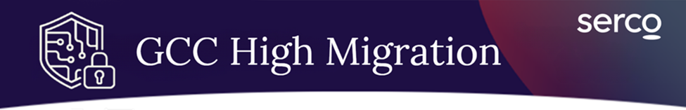
This message was sent to all employees undergoing migrations to GCC High on Monday, May 4. This was sent to both your Serco commercial and GCC High accounts.

Your M465 Data Migration is Now Complete

Beginning today, you should be operating primarily in your GCC High environment when using Outlook and OneDrive. Business Champions for your migration wave have worked to identify select SharePoint and Teams sites to migrate and cutover. M365 resources will still be accessible in ‘read-only’ mode for a temporary period.

You should continue to check your Serco commercial email weekly to ensure you don’t miss important updates, and you will need to use your Serco commercial account login to access corporate applications such as SercoConnect, ServiceNow, Deltek Timekeeping, and Concur.

What Do I Need to Do?

You should confirm that your final technology migration was successful by logging into your Serco account and verifying your data in the applications listed below:

- Exchange (Outlook): Confirm contacts, calendar, emails and tasks are available within Outlook.

- OneDrive: Check that files and folders have been copied over.

- SharePoint: Verify you have access to all your sites and the item count. Your SharePoint site mapping can be found on the Migration Registry.

- Teams: Confirm access to all teams and channels, and softphone capabilities.

Where do I go for Help?

If you experience issues in your new environment, you will have access to our migration HyperCare sessions below with the Technology Office Migration team. For any issues experienced after that date, you will need to submit a ticket in ServiceNow.

Post-Migration Hypercare
If you need additional post-migration support, join a HyperCare session during one of the dates and times offered below:

Hypercare Hours:  Monday, May 4, 12-1 pm ET  Tuesday, May 5, 12-1 pm ET  Thursday, May 7, 12-1 pm ET | Meeting Information:  Click to join the Support Bridge  Meeting ID: 256 008 278 961 94  Passcode: BA7Rt9e7

Visit the Transition Hub for more information about your data migration.

Next Steps

The Technology Office and Business Champions will provide migration guidance as we determine the roadmap for full M365 data cutover. If you have a Serco-issued commercial laptop, you will be provided with instructions to return your laptop after the full cutover has occurred.

If you have a Serco issued Commercial mobile phone, you will receive separate guidance to support your mobile transition to GCC High.
Visit the Transition Hub for more helpful information and updates.
.

PILOT – MIGRATION COMPLETE


This message was sent to all employees who partially migrated to GCC High on Monday, March 30. This was sent to both your Serco commercial and GCC High accounts.

OneDrive and Email Migration is Now Complete

You will now see that your Serco Commercial Email and OneDrive data has been copied to Serco. As a reminder, your SharePoint and Teams will remain in your commercial environment for the time being and your commercial environment will remain fully functional until a later date, which will be communicated. Your Teams Telephony capabilities have also migrated to your GCC High environment.

You should begin using your GCC High environment for email, OneDrive, and Teams Telephony.

Confirm Your Migration was Successful

You should confirm that your final technology migration was successful by logging into your GCC High account and verifying your data in the applications listed below:

- Exchange (Outlook): Confirm contacts, calendar, emails and tasks are available within Outlook.

- OneDrive: Check that files and folders have been copied over.

- Teams Telephony Softphone Capabilities: If you have a Teams Telephony softphone within Commercial, this feature and all capabilities have been migrated to your GCC High serco-na.us account. Your commercial account will no longer have the Teams Telephony softphone features.

Support Resources

If you experience issues in your new environment, you will have access to our migration HyperCare team for support this week. For future issues, you will need to submit a ticket in ServiceNow.

Post-Migration Hypercare
If you need additional post-migration support, join a HyperCare session during one of the dates and times offered below:

Hypercare Hours:  Monday, March 30, 12-1 pm ET  Tuesday, March 31, 12-1 pm ET  Thursday, April 2, 12-1 pm ET | Meeting Information:  Click to join the Support Bridge  Meeting ID: 256 008 278 961 94  Passcode: BA7Rt9e7

Visit the Transition Hub for more information about your data migration and to contact our GCC High support desk.

Next Steps

The Technology Office and Business Champions will provide migration guidance as we determine the roadmap for full M365 data cutover. In the meantime, there will be no disruption to your Serco Commercial SharePoint and Teams data. If you have a Serco-issued commercial laptop, you will be provided with instructions to return your laptop after the full cutover has occurred.

If you have a Serco issued Commercial mobile phone, you will receive separate guidance to support your mobile transition to GCC High.

*ARCHIVE: GCCH Data Migration Comm
September 17
- Subject: Reminder: It’s Coming! Prepare for your IMTS Technology Migration to Serco.
- Audience: <SATCOM & OPS>
- From: MT&S Transition Center
- To: Serco Email
- Attachment: none

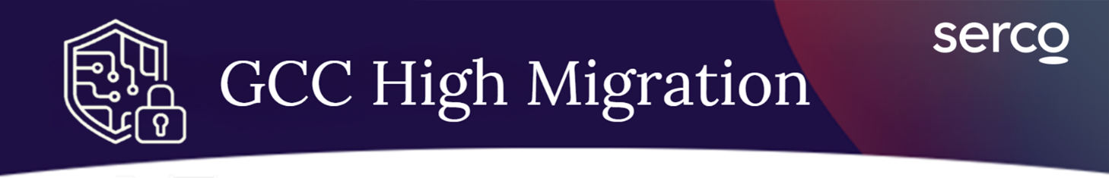
This message was sent to employees who will be migrating to GCC High during the week of March 23 and includes important information about your upcoming migration.

Reminder: GCC High Migration UAT Begins on Monday

Your migration from your NCG.com account to your Global Cloud Community High (GCCH) Serco-NA.us account is expected to occur over the weekend of October 10. Next week, you will be asked to complete user acceptance testing (UAT), for which you will receive detailed instructions to your Serco commercial & GCCH accounts.

When the migration is complete, you will be working completely from your Serco GCCH environment.

A high-level overview of milestones and actions for your migration wave is listed below:

GCC High Migration Schedule
 | Today | Notification is sent previewing migration actions.
March 23  6am ET |  | User Acceptance Testing (UAT) begins.  Instructions will be sent to your commercial and GCCH email accounts.
March 27  12pm ET |  | Deadline to complete UAT.
March 27  6pm ET |  | Data Cutover period begins.  Your data will be synced over the weekend outside of business hours.
March 30  6am ET |  | Data cutover is complete  You will now be working from your Serco GCCH (Serco-NA.us) account.

Beginning the morning on Monday, March 30, you should begin working exclusively in the GCC High M365 environment. You will receive next steps to return your commercial workstation.

What Do I Need to Do?

There are a few things that you should do to prepare for this migration:

- Familiarize yourself with the GCC High Technology Migration Center – The Technology Migration Center is the centralized hub for all migration related information and resources, providing an overview of the migration timeline and instructions to support Serco teams as you prepare to transition. Click HERE or on the banner below to access the Technology Migration Center.


- Update your Serco Commercial email signature: Update your serco-na.com email signature to inform customers and colleagues of your migration date and direct them to your serco-na.us GCCH email (see Section 2.11 of the Migration FAQs).

- Teams Softphones: Cutover Friday 3/27. If you have a Teams softphone, you will keep the same number and your features will cutover from Commercial to GCCH, and no longer have functionality from your serco-na.com environment.

- Check-in all SharePoint files that are currently checked out. Checked out SharePoint files and sites will not be migrated to the Serco environment (See Section 4.5 of the Migration FAQs for instructions to do this).

- Do not move, delete, or rename content. Your initial migration data transfer has begun, and your files will migrate as they are currently configured in your Serco Commercial account. You should not move, delete, or rename content and folders within M365 applications (Email, OneDrive, SharePoint, and Teams).

On Monday you will receive an email with instructions to complete UAT. You will have until noon ET on Friday, March 27 to complete UAT, during which you will be asked to review your migrated environment and certify that your files have migrated correctly. The time requirement for this activity may vary depending on how many files you have in your Serco commercial account. If you need help, the Technology Migration team will host a UAT Kickoff call on March 23 at 12pm ET to walk through the step-by-step instructions, followed by a UAT support session later in the week.

What else do I need to know?

Visit the Transition Hub for more information about your data migration. Here, you will find an overview of key tasks related to your specific migration timeline, FAQs, and information about receiving your GCCH laptop, if applicable.

Where do I go for help?

If you have questions or issues, please email GCCHMigrationSupport@serco-na.com.

GCCH Data Migration SharePoint/Teams Only Comm
- Deploy Date: ASAP
- Subject: Notification: Prepare for your SharePoint/Teams Sites GCC High Migration
- Audience: 92 Agile Site Owners
- From: GCCH Transition Mailbox
- To: Serco Commercial and GCCH Emails



This message was sent to Agile Impact site owners with SharePoint/Teams sites migrating to GCC High during the weekend of May 15 and includes important information about your upcoming migration.
The Serco Technology Office is getting ready to migrate your Microsoft 365 (M365) SharePoint and Teams sites from your commercial Serco-NA.com account to a new Government Cloud Community (GCC) High Serco-NA.us account. This migration is required to ensure we remain in compliance with U.S. Government security and contract requirements. When the migration is complete, you will be working primarily from your Serco GCC High environment.

A high-level overview of milestones and actions for your migration wave is listed below:

GCC High Migration Schedule
 | Today | Notification is sent previewing migration actions.
Fri, May 15  6pm ET |  | Data Cutover period begins.  Your data will be synced over the weekend outside of business hours.
Mon, May 18  6am ET |  | Data cutover is complete. HyperCare begins.  You will now be working from your Serco GCC High (Serco-NA.us) account.

Beginning Monday, May 18, you should begin working primarily in the GCC High environment. You will receive next steps to return your commercial workstation.

Next Steps:

There are a few things that you should do to prepare for this migration:

- Locate the sites migrating in this Wave. Your SharePoint & Teams site mapping can be found on the Migration Registry. Filter by your name or see all sites migrating in Wave 1B. At this time you will only be able to see the Commercial site URL. Once the site is migrated completely the GCC High site URL will appear.
- Business Champions for this migration wave have worked to identify select SharePoint and Teams sites to migrate and cutover. Please work with Business Champions to identify additional sites you may require, and we will work with them to assign a migration wave.
- M365 resources will still be accessible in ‘read-only’ mode for a temporary period. Any sites that have not already been migrated can be accessed through your Serco commercial account.

- Do not move, delete, or rename content. Your initial migration data transfer has begun, and your files will migrate as they are currently configured in your Serco Commercial account. You should not move, delete, or rename content and folders within SharePoint and Teams.

- Notify other users of this site migration. As a site owner, please notify your site owners of the upcoming migration, informing them to not use the site over the weekend, and providing the users with the new GCC High URL on Monday.

- Close out of all SharePoint and Teams applications by Friday at 6:00 pm ET. This includes SharePoint and Teams on the Commercial side and the GCC High side. Check-in any checked-out files within SharePoint prior to closing out your applications.

- After you close out of your applications, do not perform work in your Serco Commercial and GCCH accounts until return-to-work Monday, May 18 at 6:00 am ET. Any files created or modified during this migration window could fail to migrate or be overwritten.

- Teams Telephony Softphone Capabilities: If you have a Teams Telephony softphone within Commercial, this feature and all capabilities will be migrated to your GCC High serco-na.us account upon return-to-work Mon, May 18. Your commercial account will no longer have the Teams Telephony softphone features.

- Familiarize yourself with the GCC High Technology Migration Center –
The Technology Migration Center is the centralized hub for all migration related information, support, and resources. Click HERE or on the banner below to access the Technology Migration Center.


On Monday, you will receive an email confirming your migration is complete, at which time your OneDrive and email data will be 100% migrated to the GCC High environment.

Additional Resources

Visit the Transition Hub for more information about your data migration. Here, you will find an overview of key tasks related to your specific migration timeline, support contacts, FAQs, and information about receiving your GCC High laptop, if applicable.

GCC High SharePoint & Teams Migration – Migration Complete

May 18, 8am
- Subject: Your SharePoint & Teams Data Migration to Serco GCC High is Now Complete
- Audience: Site Owners
- From: GCCH Transition inbox
- To: Serco Commercial & GCCH email


This message was sent to Agile Impact site owners undergoing SharePoint & Teams migrations to GCC High. This was sent to both your Serco commercial and GCC High accounts.

Your M365 SharePoint and Teams Data Migration is Now Complete.

Beginning today, you should be operating primarily in your GCC High environment when using these select SharePoint & Teams sites. Business Champions for this migration wave have worked to identify select SharePoint and Teams sites to migrate and cutover. Please work with Business Champions to identify additional sites you may require, and we will work with them to assign a migration wave. M365 resources will still be accessible in ‘read-only’ mode for a temporary period. Any sites that have not already been migrated can be accessed through your Serco commercial account. You will need to use your Serco commercial account login to access corporate applications such as SercoConnect, ServiceNow, Deltek Timekeeping, and Concur.

What Do I Need to Do?

You should confirm that your final migration was successful by logging into your Serco account and verifying your data in the applications listed below:

- Locate the sites migrating in this Wave. Your SharePoint & Teams site mapping can be found on the Migration Registry. Filter by your name or see all sites migrating in Wave 1B. At this time, you will only be able to see the Commercial site URL. Once the site is migrated completely the GCC High site URL will appear.

- Notify other users of this site migration. As a site owner, please notify your site owners of the upcoming migration, and providing the users with the new GCC High URL.

- SharePoint: Verify you have access to all your sites and the item count.

- Teams: Confirm access to all teams and channels, and softphone capabilities.

Where do I go for Help?

If you experience issues in your new environment, you will have access to our migration HyperCare sessions below with the Technology Office Migration team. For any issues experienced after that date, you will need to submit a ticket in ServiceNow.

Post-Migration Hypercare
If you need additional post-migration support, join a HyperCare session during one of the dates and times offered below:

Hypercare Hours:  Wednesday, May 20, 12-1 pm ET  Thursday, May 21, 12-1 pm ET | Meeting Information:  Click to join the Support Bridge  Meeting ID: 271 445 754 758 158  Passcode: Si6U3Kg6

Visit the Transition Hub for more information about your data migration.

Next Steps

The Technology Office and Business Champions will provide migration guidance as we determine the roadmap for full M365 data cutover. If you have a Serco-issued commercial laptop, you will be provided with instructions to return your laptop after the full cutover has occurred.

If you have a Serco issued Commercial mobile phone, you will receive separate guidance to support your mobile transition to GCC High.
Visit the Transition Hub for more helpful information and updates.
.

BRANDING



